Bulk Email Support

📬 What Does "Bulk Email Support" Mean?
# Source: AI Source: Provided by: [Data Path: Persons Table -> ID Column: 1, Name_En Column: Motasem Essam] -> From: [ChatGPT] on [1/21/2026]
Bulk email support means a platform (like SendGrid or Mailgun) can handle sending a large number of emails efficiently, reliably, and in compliance with email standards.

🔍 In Simple Terms:
# Source: AI Source: Provided by: [Data Path: Persons Table -> ID Column: 1, Name_En Column: Motasem Essam] -> From: [ChatGPT] on [1/21/2026]
📦 Bulk email = Sending hundreds, thousands, or even millions of emails (e.g. newsletters, promotional emails, notifications)
✅ Bulk email support = The system is designed to handle, queue, throttle, and track large volumes without crashing or getting flagged as spam

🧪 Example Use Cases
# Source: AI Source: Provided by: [Data Path: Persons Table -> ID Column: 1, Name_En Column: Motasem Essam] -> From: [ChatGPT] on [1/21/2026]
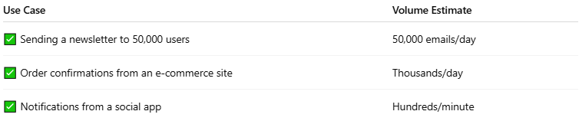

Use Case | Volume Estimate
✅ Sending a newsletter to 50,000 users | 50,000 emails/day
✅ Order confirmations from an e-commerce site | Thousands/day
✅ Notifications from a social app | Hundreds/minute

✅ Features of a Bulk Email–Capable Service
# Source: AI Source: Provided by: [Data Path: Persons Table -> ID Column: 1, Name_En Column: Motasem Essam] -> From: [ChatGPT] on [1/21/2026]
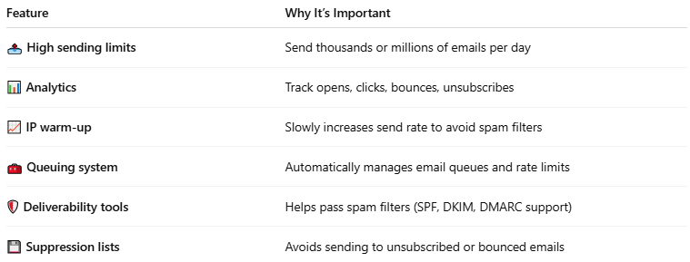

Feature | Why It’s Important
📤 High sending limits | Send thousands or millions of emails per day
📊 Analytics | Track opens, clicks, bounces, unsubscribes
📈 IP warm-up | Slowly increases send rate to avoid spam filters
🧰 Queuing system | Automatically manages email queues and rate limits
🛡️ Deliverability tools | Helps pass spam filters (SPF, DKIM, DMARC support)
💾 Suppression lists | Avoids sending to unsubscribed or bounced emails

❌ Why Normal SMTP or PHP mail() Is Not for Bulk Email
# Source: AI Source: Provided by: [Data Path: Persons Table -> ID Column: 1, Name_En Column: Motasem Essam] -> From: [ChatGPT] on [1/21/2026]

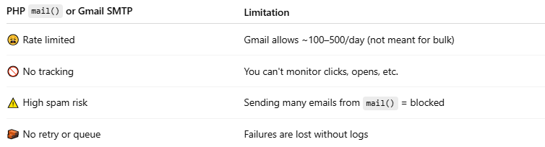

PHP mail() or Gmail SMTP | Limitation
😩 Rate limited | Gmail allows ~100–500/day (not meant for bulk)
🚫 No tracking | You can't monitor clicks, opens, etc.
⚠️ High spam risk | Sending many emails from mail() = blocked
🧱 No retry or queue | Failures are lost without logs

a regular mail server (like Gmail SMTP or your local server) is not designed for bulk email.

✅ Platforms with Bulk Email Support
# Source: AI Source: Provided by: [Data Path: Persons Table -> ID Column: 1, Name_En Column: Motasem Essam] -> From: [ChatGPT] on [1/21/2026]
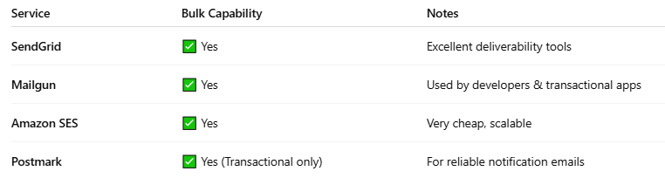

Service | Bulk Capability | Notes
SendGrid | ✅ Yes | Excellent deliverability tools
Mailgun | ✅ Yes | Used by developers & transactional apps
Amazon SES | ✅ Yes | Very cheap, scalable
Postmark | ✅ Yes (Transactional only) | For reliable notification emails

📌 Summary
# Source: AI Source: Provided by: [Data Path: Persons Table -> ID Column: 1, Name_En Column: Motasem Essam] -> From: [ChatGPT] on [1/21/2026]
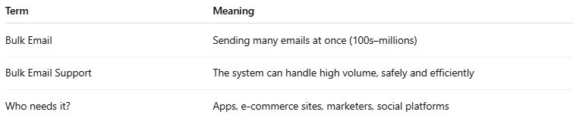

Term | Meaning
Bulk Email | Sending many emails at once (100s–millions)
Bulk Email Support | The system can handle high volume, safely and efficiently
Who needs it? | Apps, e-commerce sites, marketers, social platforms

